**CS412 Machine Learning**

# HW 2 – Probabilities – Bayesian Learning

# 100pts

* **Please TYPE your answer or write legibly by hand (pts off if it is hard to read).**
* **Use this document to type in your answers** (rather than writing on a separate sheet of paper), so as to keep questions, answers and and grades together to facilitate grading.
* **SHOW all your work for partial/full credit.**
* **Allocated spaces should be enough for your answers** (unnecessarily long and irrelevant answers may loose points)

**1) 20 pt -** Suppose that we have 3 colored boxes r (red), b (blue) and g (green).

Box r contains 9 apples, 5 oranges and 3 limes;

Box b contains 8 apples, 4 oranges and 1 limes;

Box g contains 5 apples, 2 oranges and 6 limes.

Assume a process **where we pick a box first and then pick a fruit from the selected box**. A box is chosen at random according to the following probability of being selected: p(r) = p(b) = 0.3 and p(g)=0.4 and a piece of fruit is selected from the **chosen** box randomly.

1. 10 pt – What is the **probability of selecting an orange**?

b) 10pt - If we **observe that the selected fruit is an orange**, what is the probability that it came from the red box?

**2) 40 pt - For a 2-dimensional input space, we are given the following class conditional probability densities. Assume that $x_{1}$ and $x_{2}$**  **are conditionally independent given class names.**

p(|C1) = 1/3 for 0 <= <= 4

0 elsewhere

p(|C1) = 1/4 for 0 <= <= 4

p(|C2) = 1/2 for 4 <

0 elsewhere

0 elsewhere

p(|C2) = 3/4 for 4 <

0 elsewhere

Assume P(C1)=P(C2)=0.2 and P(C3)=0.6.

1. **12pt – Draw the corresponding pdfs for $x_{1}$ and $x_{2}$**  **, being as precise as possible** (e.g. **label axes and important points on the axes**). You can draw by hand, take a picture and include here as image.
2. **10pts -** **Develop a classification strategy for given feature values** (just looking at the graph – no formula), just complete the sentence(s):

if $x_{1}$ is in the region ............., and $x_{2}$ is in the region ............. , I will classify it as …......................;

if $x_{1}$ is in the region ............., and $x_{2}$ is in the region ............. , I will classify it as …......................;

Otherwise, I will classify it as …......................;

**c) 8pts -** **Draw the decision regions.**

**d) 10pts – Give a one line qualitative answer** (no precise numbers/thresholds...) **& reasoning for each case below (**how your decision changes or whether it doesn’t).

* Would your decision strategy change if P(C1)=0.8 and P(C2)=P(C3)=0.1?
* How about if it was the reverse P(C1)=P(C3)=0.1 and P(C2)=0.8?

**3) 40pts –** **NAIVE BAYES**

**a) 10pts – Given that two random variables X and Y are conditionally independent given C, circle True or False** (2pts for each correct answer; -1pts each wrong answer):

* P(X| Y ) = P(X) True / False
* P(X | Y, C ) = P(X | Y) True / False
* P(X , C | Y ) = P(X | Y ) True / False
* P(X ,Y | C ) = P(X | C) P(Y | C) True / False
* P(X ,Y , C ) = P(X | C) P(Y | C) P(C) True / False

**b) 24pts - Using the Mammal dataset given below**, **how would you classify the animal that give birth, cannot fly, sometimes live in water, and has not legs, using Naive Bayes classifier *without any smoothing*. Show your work** (e.g. indicate class conditional attribute probabilities under the given table in the next page and just transfer them here).

P(mammal| x) =

P(non-mammals| x) =

**Decision: ..............................**

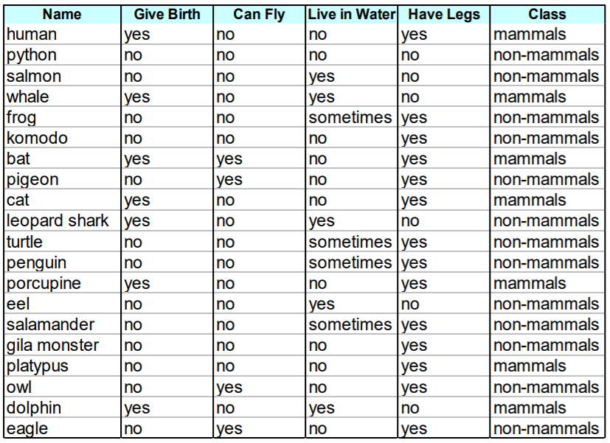

**Write here the estimated probabilities (you should only write those related to the question for simplicity):**

P(Give Birth=Yes | mammal) = .......

....

**c) 6pts - Without re-doing the whole process, calculate the probabilities for P(Live in Water|mammals), P(Have Legs|mammals) and P(Give Birth|non-mammals) using Laplace smoothing:**

P(Live in Water=Sometimes|mammals) = .......................

P(Have Legs=No|mammals) = .........................

P(Give Birth=Yes|non-mammals) = .........................